Lab 3: Advanced Tableau:

Name:

1. Dual Axis and Combo Charts:
(1). Create a Dual Axis with Month of the Order Date, Sum of the Tax Amount, and Sum of the Sales Amount;
(2). Change the axis at the same unit of analysis;
(3). Use different chart types in one view: combo chart:

2. Building a combined axis chart:
(1). Add sum of the Tax Amount, sum of the Unit Price, sum of product standard cost in a combined axis chart, categorized by Product Line:
(2). Use Measure Names in the filter to add sum of product cost in the combined axis:
(3). Use color marks for additional comparison;
(4). Create a combined axis stacked chart;

3. Create Scatter Plot:
(1). Create scatter plot with two measurements (cost and sales)(aggregated), but add dimensions for more detail;
(2). Create scatter plot with two measurements (non-aggregated);

4. Creating a symbol map:
(1). Create a map view to compare sum of the sales amount by country;
(2). Create a map view to compare sum of the sales and sum of the total product cost using sizes and colors; Edit Map layers to change the map view.

5. Cross Table: Working with Totals and Aggregation:
(1). Add Grand Totals to the rows and columns, add all subtotals (Country, Product Line, Color and Sum of Sales);
(2). Change the sum aggregation to the averages, and change the labels;
(3). Use “Total All Using” to average the values in the View;

6. Cross Table: Creating Highlight Tables and Heat Maps:
(1). Create highlight table highlighting the Sum of Order quantity ordered from different model names from different customers: Set color center to 10.
(2). Create a heat map in the crosstab to compare the product cost and unit price in different regions from different product line.

7. Create the calculated fields:
(1). Create the calculated fields: Unit profit = unit price – product standard cost; Total profit = unit profit * order quantity; Profit Margin = total profit/sales amounts; Overall average profit margin = average (total profit)/ average (sales amounts);
(2). Compare the average of profit margin and overall average margin profit by the product line;

8. Create Calculations using strings, mix types, and date functions:
(1). Create a “Customer Full Name” field that concatenate “First Name”, “Middle Name” and “Last Name”;
(2). Create a concatenate field including “Customer Full Name” and yearly income;
(3). Use the date difference function to calculate the date/month differences;

9. Running total and percentage of the total:
(1). Create the running total and percentage of the total using pane across (Due Date, Product Line, Color and Sales Amount;
(2). Create ranks using quick table calculation (Country, Region, and Profit);

Question 1:
This table shows a quick table calculation using percent of total. How was it computed?
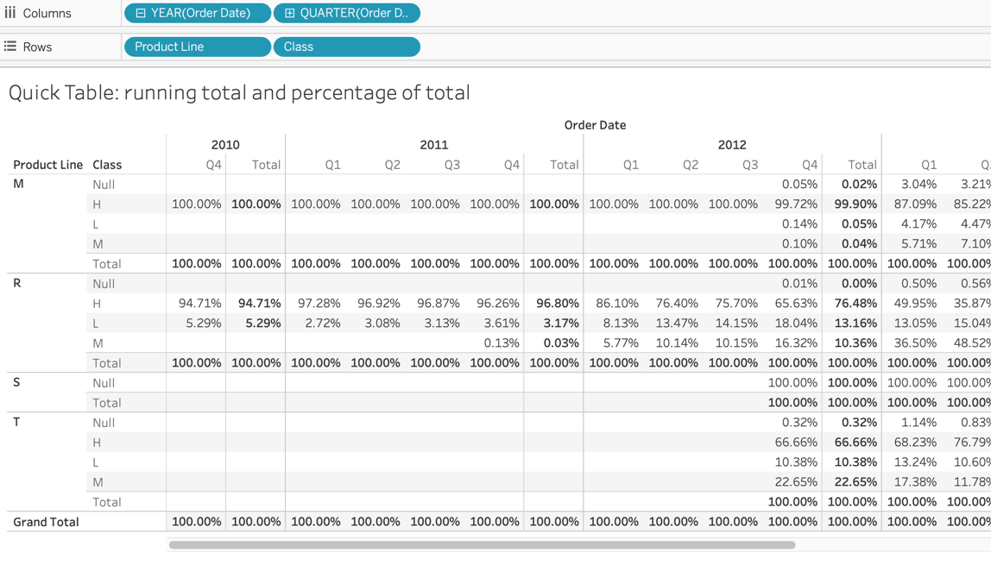
a. Table (across)
b. Table (down)
c. Pane (across)
d. Pane (down)

Question 2:
The table calculation has a compute using value of Table. If we change the value to Cell, what do you expect the outcome to be?
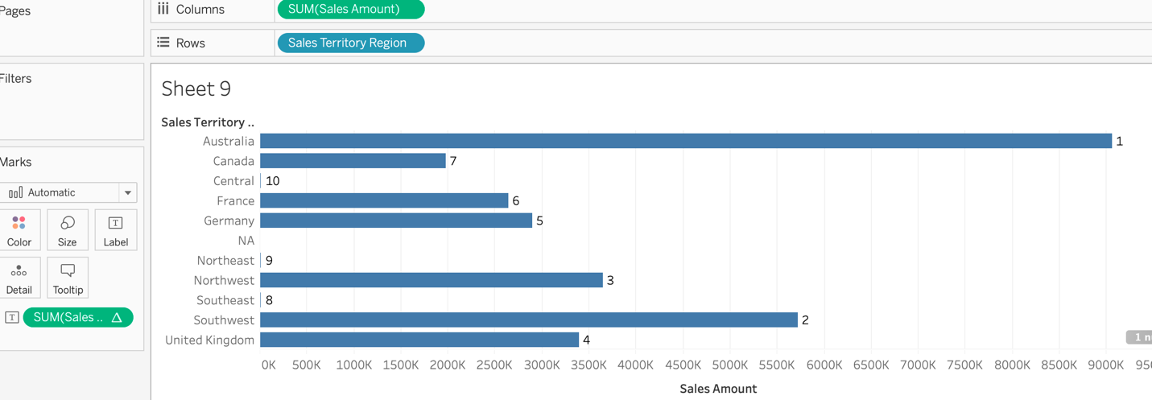
a. All regions are ranked as 1;
b. Each region is ranked against all other cells;
c. Countries are ranked against the countries in their region;
d. Regions are ranked by their best year.

10. Advanced Calculation: Aggregate Dimension:
(1). Aggregate dimensions using max, min, count, count distinct, attribute;
(2). Create a new field: Profitable (avg of unit profict) by Product Line, categorizing product lines into two levels: Profitable and Non-profitable:

Question 3:
You would like to know the number of unique codes are in your sales region. Which aggregation would you select?
a. Count distinct;
b. Attribute;
c. Minimum;
d. Maximum;

11. Union data and merge fields:
Use nuts data;
(1). Union all the tables (almonds, hazelnuts, macadamias, pistachios, walnuts) into one data source;
(2). Merge fields that are not correctly identified, and rename the columns that are misidentified;

12. Showing statistics and forecasting: use the analytics pane and trend lines:
(1). Build a trend line between weight and standard cost, enable confidence interval, are the correlation coefficient between these two facts significant?
(2). Generate a forecast in the View: build a forecast line to predict the sum of sales amount in 2015 (order date);

13. Find Clusters in Data:
(1). Find clusters in the scatterplot of weight and product cost from production dimension; How many clusters are generated automatically? Distinguish these clusters using different colors;
(2). Display only cluster 1 and cluster 2 in the view; Save clusters as groups in the data field, and rename the groups;

